Deborah Barndt

Lab 3: Quotes

ITMD 455-02

2-15-17

Screenshot of the Quotes icon

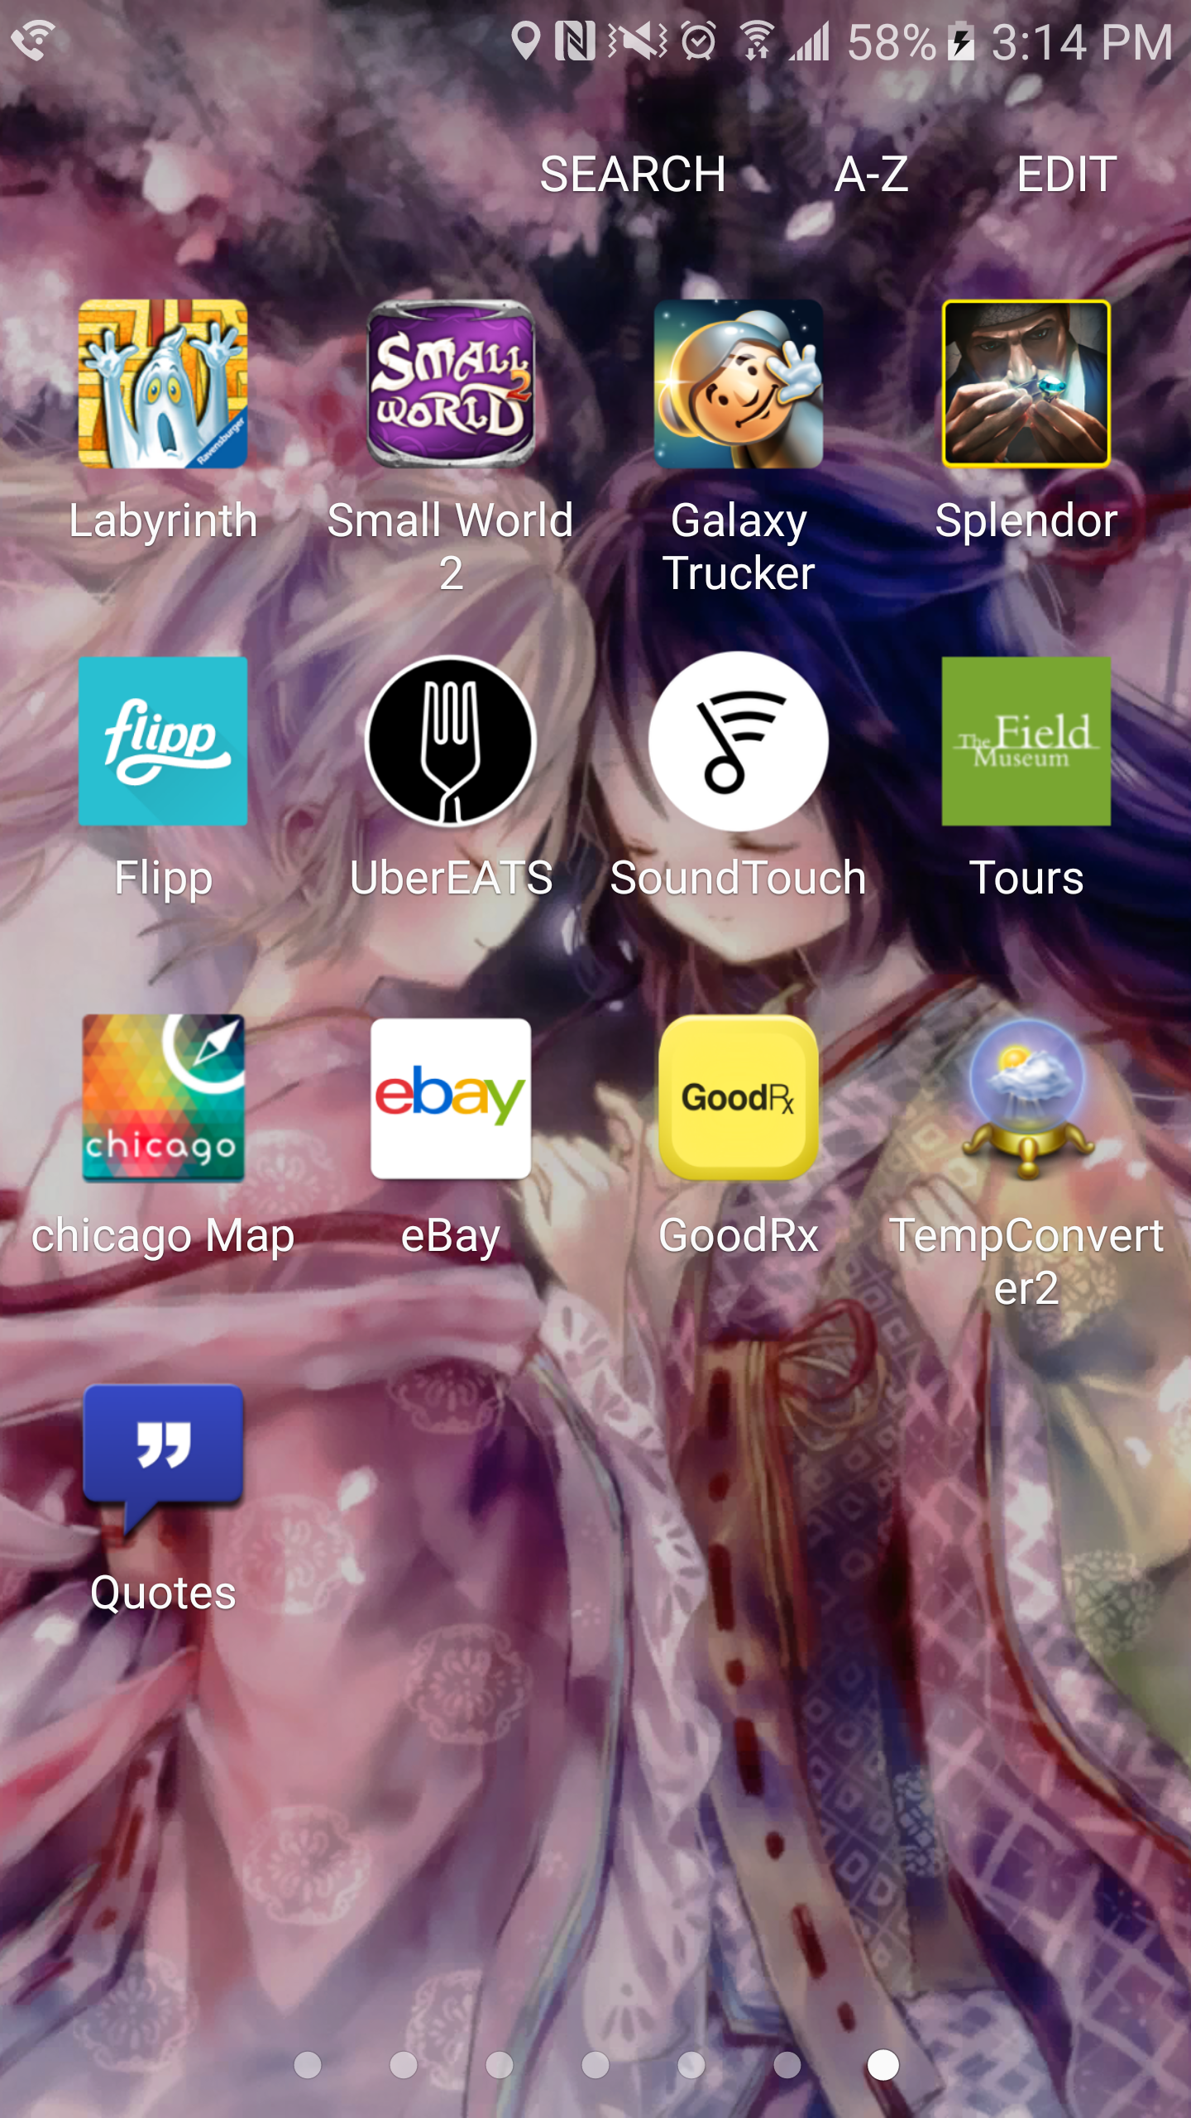

Screenshot of splash screen

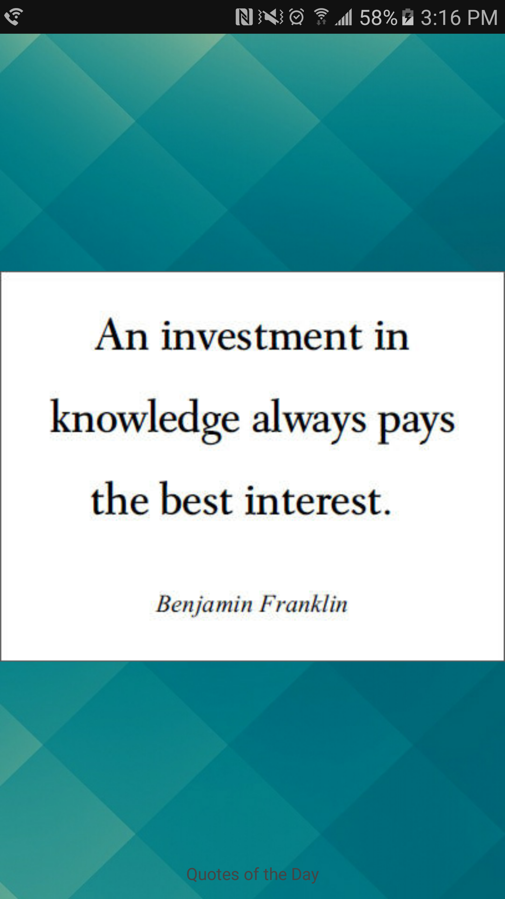

Screenshots of the Master View Quotes

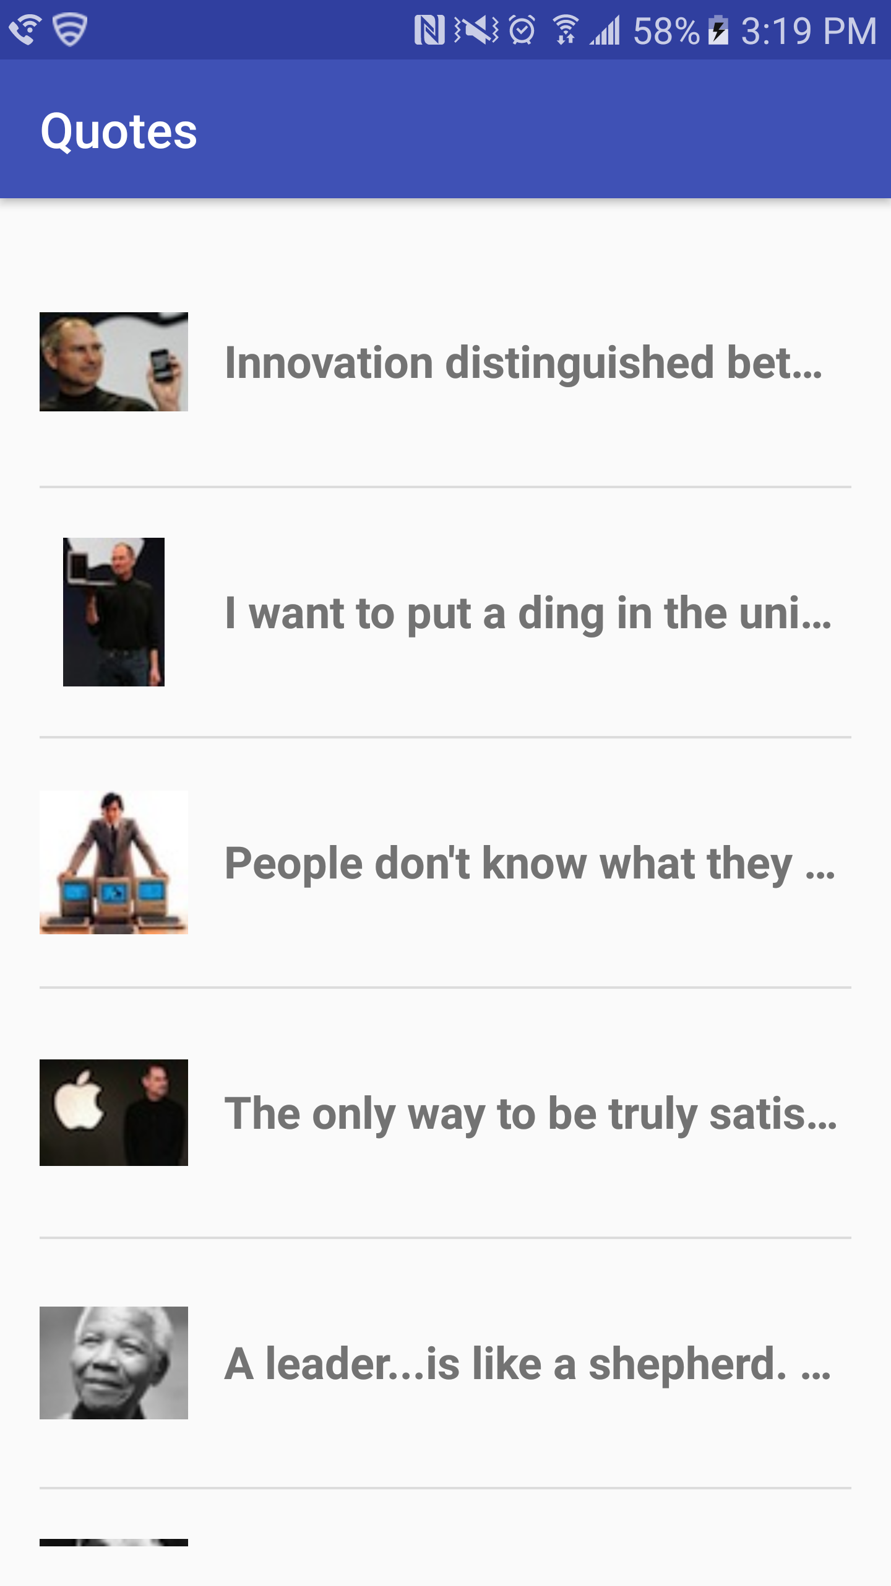

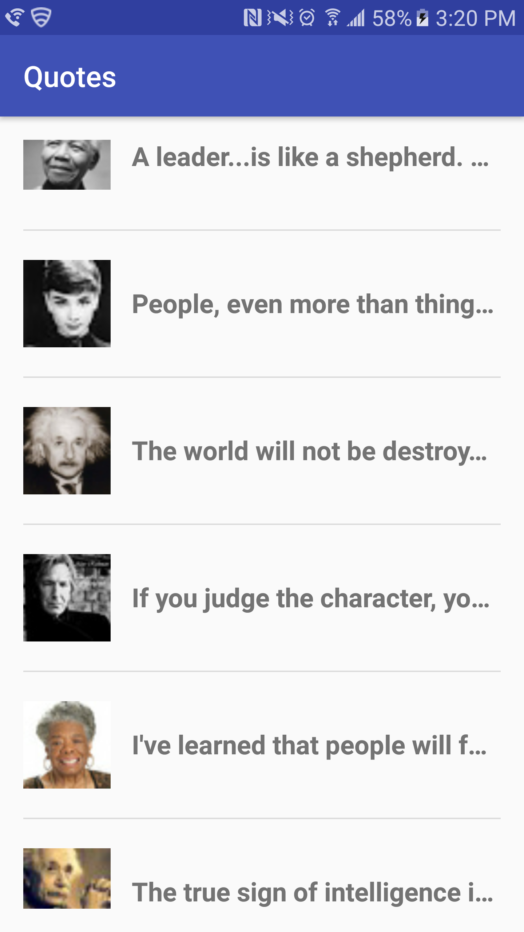

Screenshot of Detail View



Screenshot of Detail View with scroll



Screenshot of Detail View

